**“GREECE, CYPRUS AND THE GREEK ISLANDS”**

**- 12 DAYS IN THE SUN -**

Monday May 9, 2022 – Saturday May 21, 2022

**$3,795.00**

**Single Supplement: $495.00**

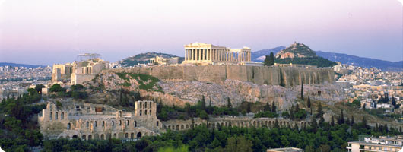 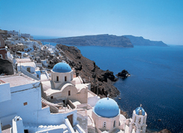

**Athens Santorini**

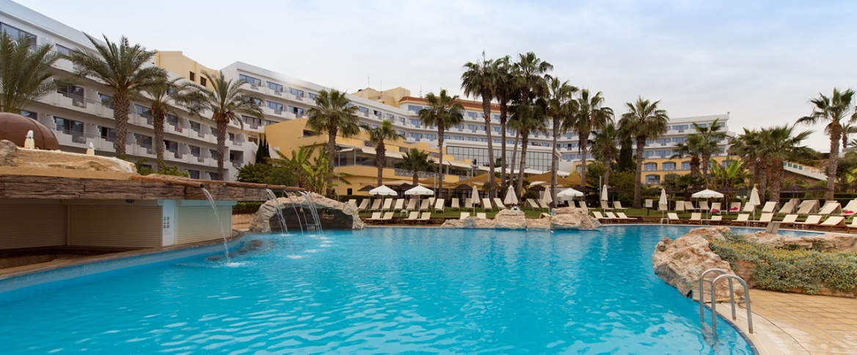

**St. George Hotel – Paphos, Cyprus** [www.stgeorge-hotel.com](http://www.stgeorge-hotel.com)

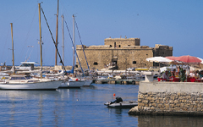

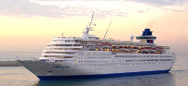

**Celestyal Olympia**  [www.celestyalcruises.com](http://www.celestyalcruises.com)  **Paphos, Cyprus**

Visit the beautiful Mediterranean resort island of **Cyprus** with miles of golden beaches, temples, castles, mosaics, 340 days of sunshine and 10,000 years of history and civilization.

Spend **5** days on the island of Cyprus, **2** nights in **Athens,** and as a bonus enjoy an unforgettable **4-day** magical cruise to the ***Greek Islands*** where you will get to know the wonderful world of the islands and the great sites of Greek culture and hospitality.

**\*Price is based on double occupancy and includes round trip airfare, hotel accommodations with breakfast, all group meals, guided tours and entrance fees per itinerary, 4-day cruise to the Greek Islands, and all transfers.**

***All accommodations described are as of today. If it becomes necessary to make changes, accommodations will be of the same or better Value, Class and/or Rating.***

Note: Flight will depart from Newark. Bus transportation from Greensburg to the airport will be available. The cost for the bus (approximately $155.00 per person/round trip) will be shared by those who take advantage of this convenient and inexpensive way to get to the airport ***(see below in RED)*.**

---------------------------------------------------------------------------------------------------------------------------------------------------

**TENTATIVE ITINERARY**

**DAY 1 - MONDAY MAY 9, 2022:**

***1:00 pm –*** *Bus departs Greensburg for Newark Airport.*

***9:00 pm –*** *Bus arrives at Newark Airport.*

**11:55 pm –** Depart Newark for Athens, Greece on Emirates Airlines flight # 210

**DAY 2 - TUESDAY MAY 10, 2022:**

**4:10 pm –** Arrive in Athens.

**6:40 pm –** Depart Athens for Larnaca, Cyprus on Aegean Airlines flight # 908

**8:25 pm –** Arrive Larnaca, Cyprus and go directly to the hotel.

Hotel - St. George Hotel – Paphos, Cyprus

[www.stgeorge-hotel.com](http://www.stgeorge-hotel.com)

Meals Included:  **Breakfast, Lunch and Dinner (on the plane)**

**DAY 3 – WEDNESDAY MAY 11, 2022:**

Breakfast at the hotel

**10:00 a.m.** Leave the hotel for a tour of:

a. Tombs of the Kings: A wide area containing underground tombs carved out of solid rock dating to 4th century BC, many decorated with Doric pillars. Whether Kings were buried here or not, the magnificence of the tombs gave the locality its name.

b. The Mosaics of Pafos (also known as the House of Dionysus): The amazing mosaic floors of these 3rd century AD villas are considered among the finest in the world. The mosaic pavements are composed of magnificent designs of great artistic values and their colors still retain their original brightness. They mostly depict scenes from Greek mythology. Excavation of the House of Dionysus began in 1962 when a farmer accidentally uncovered a piece of a mosaic floor while plowing his fields.

c. Pafos Odeon: This ancient amphitheater is located on the east side of the Lighthouse. It has suffered much damage during the years, but was recently been partly restored. It consists of the auditorium, the orchestra and the stage building. It was entirely built of stone and it dates to the 2nd century AD. It was destroyed during severe earthquakes of the 4th century AD and it was used as a refuge by the early Christians. It was finally abandoned during the Arab raids of the 7th century AD.

d. Ayia Solomoni Catacomb: The catacomb consists of a complex of underground chambers opening around an open court. It is believed that it might have been used for some other purpose before it was transformed to its use as a Christian refuge. A sacred tree stands at the top, which, according to tradition, cures the diseases.

e. Panayia Chrysopolitissa Church: A Latin Church in Gothic style which was excavated in recent years. Erected about 1300 AD, it is probably the church of the Franciscan convent of Pafos. Next to the Gothic Church and around and below the later church of Ayia Kyriake lay the remains of what might be one of the largest ever Basilica Churches. The floor was paved with colorful mosaics many of which still survive in good condition.

f. St. Paul's Pillar: St. Paul visited Pafos in the year 45 AD and according to tradition, he was bound to this pillar and was given 39 lashes as punishment for preaching Christianity.

**1:00 pm -** Lunch

Afternoon free.

**8:00 pm** - Dinner

Hotel - St. George Hotel – Paphos, Cyprus

[www.stgeorge-hotel.com](http://www.stgeorge-hotel.com)

Meals Included: **Breakfast Lunch and Dinner**

**DAY 4 – THURSDAY MAY 12, 2022:**

Breakfast at the Hotel

**8:30 a.m.** Visit the Old Market in uptown Paphos. An opportunity to do your souvenir shopping or just enjoy a beverage at a local Restaurant. Stop at a Ceramics workshop and learn how the beautiful ceramic pottery is made, and then follow the mountain scenic route to reach **Letymbou** village, and pay a visit to the traditional house of **Sofia**, where the welcoming host will introduce us to local culinary traditions and offer real Cypriot lunch of fresh halloumi cheese, olives, freshly baked country bread, lamb, roasted chicken, roasted potatoes, and more……..

**1:00 p.m.** Lunch as a group at ***Sofia’s*** House

Afternoon and evening ***Free***

Hotel – St. George Hotel – Paphos, Cyprus

[www.stgeorge-hotel.com](http://www.stgeorge-hotel.com)

Meals Included: **Breakfast and Lunch**

**DAY 5 – FRIDAY MAY 13, 2022:**

Breakfast at the hotel

***Free Day***

Hotel – St. George Hotel – Paphos, Cyprus

[www.stgeorge-hotel.com](http://www.stgeorge-hotel.com)

Meals Included: **Breakfast**

**DAY 6 – SATURDAY MAY 14, 2022:**

Breakfast at the hotel

**8:30 a.m.** Leave the hotel for the airport. On the way, drive through the hills and villages with a stop at a traditional village in the Mountains. Meet the friendly locals and enjoy a magical walk in the old narrow streets. In addition – time permitting – visit the following Archaeological sites:

**a. Kourion:** An important ancient city kingdom, and one of the most interesting and spectacular archaeological sites on the island with excavations still bringing new treasures to light. The magnificent Graeco-Roman theater was originally built in the 2nd century BC and enlarged in the 2nd century AD. It is now fully restored and used for musical and theatrical performances. The House of Eustolios was originally a private villa, and in the early Christian period became a public recreation center. It consists of a complex of baths and a number of rooms with beautiful 5th century mosaic floors. The early Christian Basilica dates to the 5th century and was probably the Cathedral of Kourion with a baptistery attached to the north side. The House of Achilles and the House of the Gladiators have beautiful mosaic floors.

**b. Kolossi Castle:** A stronghold a few kilometers outside the city of [Limassol](http://en.wikipedia.org/wiki/Limassol), it held a great strategic importance and contained production of sugar, one of Cyprus' main exports in the [Middle Ages](http://en.wikipedia.org/wiki/Middle_Ages). The original castle was possibly built in 1210 by [Frankish](http://en.wikipedia.org/wiki/Franks) military when the land of Kolossi was given by [King Hugh I](http://en.wikipedia.org/wiki/Hugh_III_of_Cyprus) to the [Knights of the Order of St John of Jerusalem](http://en.wikipedia.org/wiki/Knights_Hospitaller) (Hospitallers) and the present castle was built in 1454 by the Hospitallers. In addition to the Hospitallers, dwellers in the castle include [Richard the Lionheart](http://en.wikipedia.org/wiki/Richard_I_of_England)  and the [Templars](http://en.wikipedia.org/wiki/Knights_Templar).

**c. Sanctuary of Apollo:** Apollo Hylates, God of the Woodland, was the protector of the city of Kourion. Archaeological evidence shows that the cult of Apollo was celebrated here from the 8th century BC to the 4th century AD.

**1:00 pm** - Lunch

Depart Cyprus for Athens late afternoon/early evening

Arrive in Athens and go directly to the Hotel.

Hotel – Titania Hotel - Athens, Greece

[www.titania.gr](http://www.titania.gr)

Meals Included: **Breakfast and Lunch**

**DAY 7 – SUNDAY MAY 15, 2022:**

**8:30 am.** After breakfast at our hotel in Athens, ½ day tour of Athens. We will see the Tomb of the Unknown Soldier, the Royal Palace, the Temple of Olympian Zeus and the Pan-Athenian Stadium where the first Modern Olympics took place in 1896. We will also visit the Acropolis with all the monuments including the Parthenon.

An ancient city with a distinctly modern flair, Athens is a place where astonishing ruins share center stage with today's high-rises. It's a city where 2,500-year-old monuments remain models of grace and harmony - seemingly worlds away from the 21st-century pulse of this dynamic metropolis.

The Acropolis rises 200 feet above the city, capped by the magnificent Parthenon. Best seen early in the morning before the throngs arrive, the Acropolis is home to several other exquisite temples. The Propylaia, the colossal gateway dating back to the 5th century B.C., leads to the carefully restored Temple of Athena Nike, while the Erechtheion, with its renowned carvings of the Caryatids, or six maidens (the originals are in the Acropolis Museum), stands on the far side of the Sacred Way. From the summit, you'll enjoy a clear view of the remains of the theater of Dionysus and of the Agora, once the city's commercial and civic center. The Acropolis is striking at sunset, when the Parthenon's pale marble takes on a golden glow-and dazzling by night, when these elegant monuments are fully illuminated.

Classical antiquities are far from Athens' only attractions. For contemporary charm, stroll the Plaka, the city's oldest neighborhood, an area of winding streets and alleys, candy-colored walls, wrought-iron balconies brimming with geraniums, small churches, and festive tavernas. You can sample Athens' bounty and satisfy your appetite as you stroll along the streets.

Hotel – Titania Hotel - Athens, Greece

[www.titania.gr](http://www.titania.gr)

Meals Included: **Breakfast**

**Day 8 – MONDAY MAY 16, 2022:**

**8:00 a.m.** After breakfast depart the hotel for Piraeus to board the cruise ship for a 4-day cruise to the Greek islands and Turkey. The first port of call is the island of **Mykonos**, where beautiful beaches, chic boutiques and elegant nightclubs all vie for the tourist’s attention. Beneath its sophisticated surface, however, lies a quintessential Greek island. Hundreds of tiny chapels dot the island and sheep graze in the shadow of whitewashed windmills. Find a table on the waterfront and bask in the serenity of sunset over the picturesque harbor.

Meals Included: **Breakfast Lunch and Dinner**

**DAY 9 – TUESDAY MAY 17, 2022:**

We arrive at **Kusadasi** in Turkey. An optional tour of nearby **Ephesus** should not be missed, for here, history truly comes to life. Walking towards the ancient harbor, down a marble road rutted by the wheels of countless chariots, one will pass such architectural masterpieces as the Magnesia Gate and the Library of Celsus before arriving at the Great Amphitheater where St. Paul was arrested and cast out of the city.

In the later part of the afternoon, we will arrive on the island of **Patmos**.** This serene island is known as the site of the apocalyptic revelations of St. John the Divine, written here during his exile from the Roman Empire. The cave where he is said to have lived is now the site of the Monastery of the Apocalypse. In the 11th century, the Abbot Christodoulos founded the Monastery of St. John on one of the island’s highest points. It houses priceless icons and manuscripts in its treasury.

Meals Included: **Breakfast Lunch and Dinner**

**DAY 10 – WEDNESDAY MAY 18, 2022:**

After breakfast, we have the opportunity to visit the beautiful island of **Rhodes** with its rich and varied history. On a hill above the charming town of Lindos, rises an ancient acropolis dedicated to the goddess of Athena. Below, lay the Bay of St. Paul, where the apostle landed during his voyages. The crusading Knights of St. John left the magnificent medieval city of Rhodes behind when Sultan Suleyman the Magnificent defeated them. The Turks then occupied Rhodes for almost 400 years leaving mosques, minarets and a Turkish bath to mark their presence.

Meals Included: **Breakfast Lunch and Dinner**

**DAY 11 – THURSDAY MAY 19, 2022:**

Good morning, and welcome to the island of **Crete.** After breakfast, one has a choice of excursions to visit Heraklion, the capital of Crete and its principal commercial port. Just 3-miles away are the fantastic ruins of the Palace of Knossos. Discovered in 1899 by Sir Arthur Evans and partially reconstructed, the elaborate Palace is believed to be the mythical Labyrinth of King Minos and the seat of ancient Minoan culture.

This afternoon, we will sail to the island of **Santorini**,** perhaps the most breathtaking of all Greek islands. Around 1500 B.C., a volcanic eruption destroyed the center of the island, leaving a crescent shaped rim of cliffs around a harbor formed in the volcano’s caldera. The town of Fira, with its whitewashed houses, narrow streets, open-air cafes and glittering boutiques, clings to these cliffs, accessible mostly by foot (approximately 600 steps), cable car or donkey. To the south is Akrotiri, where recent Minoan excavations support the theories that Santorini might be the fabled lost continent of Atlantis. The town of Oia is also very impressive with beautiful view and nice shops.

Meals Included: **Breakfast Lunch and Dinner**

**DAY 12 – FRIDAY MAY 20, 2022:**

After breakfast, we will disembark and go straight to Athens Airport for our return flight.

**5:20 pm –** Depart Athens for Newark on Emirates flight # 209

**9:20 pm –** Arrive Newark

**10:00 PM –** Check-in at Best Western Plus Hotel, Newark Airport West.

Meals Included: **Breakfast (on the ship), Dinner (on the plane)**

**DAY 13 – SATURDAY MAY 21, 2022:**

***9:00 am*** *- Depart the hotel by bus for Greensburg.*

***4:00 pm –*** *Arrive Greensburg.*

Meals Included: **Breakfast**

***\*\*Disembarkation by tenders – weather permitting.***

***Cruising the Greek Islands has gained in popularity for very good reason. It's a relaxing and convenient way to experience local culture, history and cuisine while enjoying the comfort of a cruise ship. However, please be aware of potential conditions which may impact your cruise. While most of the time cruises operate exactly as planned, weather conditions may result in skipping a stop at an island – especially where disembarkation is done by tenders.***

**Testimonials**

***- “An amazing trip on so many levels. Thank you for making it all possible”***

***- “We will never forget this trip….. We will be talking about this for years”***

***- “Thank you for a trip of a lifetime”***

***- “Two fabulous weeks, 46 great travel partners and one great leader…..Thanks for a terrific time”***

***- “Thank you for making our trip so memorable. You are so generous with your time and seeing to every detail”***

***- “Your caring, competent, fun-loving ways as a host and guide made our trip very enjoyable….”***

***- “Thank you for a lovely trip…Those two weeks shall hold a special meaning in my book of memories…”***

***- “What a wonderful time I had! Food was excellent, the group was super and the best of all was you, Lefty, for making it all happen…”***

***- “Thank you for the ‘unbelievable trip’ you planned. When I am asked by people about the trip I am truly at a loss for words to describe it…”***

***- “Thank you, thank you, thank you! The trip was wonderful. It was everything you said it would be and more. We will think about it and talk about it for years….”***

***- “Thank you for all you did before, during and after our trip to make this vacation so wonderful. What a blessing it was to see all the sights, meet all the terrific people and bring home memories of a lifetime.”***

***- “We salute you for producing such a superb trip; you are our leader extraordinaire! We had a fabulous adventure because you did such a tremendous job in handling all of the details.”***

***- “I can’t begin to tell you what a wonderful trip you planned for us. Many thanks for all the wonderful arrangements – you made every day so special…”***

**Terms and Conditions:**

Deposit of **$500.00** per person due at time of booking. The organizer acts only as your agent in managing the various accommodations and assumes no responsibility or liability in connection with any aircraft, motor coach or other conveyance, restaurant, excursions, sightseeing, or hotel accommodations in the performance of this tour. In the event it becomes necessary or advisable to alter the itinerary, such alterations will be made. Any additional expenses will be borne by the passenger(s).

***Note:* *Airline/airport taxes/fees, fuel surcharge, and any increases due to exchange rate fluctuations will be reflected in the final invoice.***

The tour is limited in size. In the event the tour is over-subscribed, reservations will be confirmed by the date deposit is received.

To reserve your seat(s), or to obtain additional information, call/text (724-331-6805) or e-mail Terry (“Lefty”) Pistentis or return the attached Reservation Form to the address below. You can also reserve your seat(s) by calling in your Credit Card information.

Make checks payable to: ***“Fanari Travel”***and mail to:

Fanari Travel

PO Box 846

Greensburg PA 15601

Cell: 724-331-6805

E-mail: [fanaritravel@gmail.com](mailto:fanaritravel@gmail.com)

✁---------------------------------------------------------------------------

**Reservation Form**

Please Reserve:

___ Seats for the “***Greece, Cyprus and Greek Islands – 2022*”** Tour.

Enclosed please find check for $ _______ payable to: ***“Fanari Travel”.*** I/we understand that in case of cancellation, the following refund policy applies:

* Up to February 8, 2022: ***Full Refund***.
* February 9, 2022 – April 8, 2022: $500.00 Cancellation Penalty per person.
* 30 days or less or no-show (April 9, 2022 – May 9, 2022): No refund.

***---------------------------------------------------------------------------------------------------------------------------------------------------------------***

**PASSPORT INFORMATION EXACTLY AS IT APPEARS ON THE PASSPORT:**

***(Note: For dates, please use the day/month/year format and spell out the month.***

***Example:******7 MAY 1956****)*

**NAME(S)** (*exactly as it appears on the Passport*):

*(Make copies for additional names, if needed)*

FIRST:________________________ MIDDLE: ____________________ LAST:_____________________

DATE OF BIRTH ____________________________________

PASSPORT NUMBER ________________________________

PASSPORT EXPIRATION DATE _______________________________________

=================================================================================

FIRST:________________________ MIDDLE: ____________________ LAST:_____________________

DATE OF BIRTH ____________________________________

PASSPORT NUMBER ________________________________

PASSPORT EXPIRATION DATE _______________________________________

=================================================================================

Address: ____________________________________________________________

____________________________________________________________________

Phone (Home): _____________________________________________________

Phone (Cell): ______________________________________________________

E-mail: _____________________________________