“A TASTE OF ITALY – 2022”
Friday May 27, 2022 – Monday June 6, 2022
$3,695.00* per person
Single Supplement: $495.00

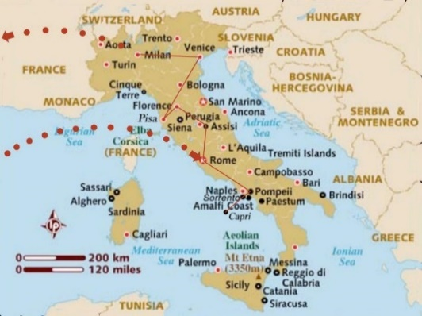
An opportunity to discover Italy and get a taste of Roman culture, history and cuisine by visiting Rome - the famous eternal city, the Vatican - with all its museums and chapels, Florence - the cradle of the Renaissance and one of the most majestic cities in the world, Venice - the city built on 177 islands, 150 canals and 400 bridges, Pompeii - the famous Roman city destroyed by the eruption of the volcano Vesuvius in 79 A.D., the Amalfi Coast with breathtaking views, Pisa, Assisi, and many more.
*Price is based on double occupancy and includes round trip airfare from Newark, hotel accommodations in Rome, Sorrento, Florence, and Venice, all group meals, guided tours and entrance fees per itinerary, and all transfers.
Note: Flight will depart from Newark. Bus transportation from Greensburg to the airport will be available. The cost for the bus (approximately $155.00 per person/round trip) will be shared by those who take advantage of this convenient and inexpensive way to get to the airport).

TENTATIVE ITINERARY

DAY 1 – FRIDAY MAY 27, 2022:

5:15 p.m. – Depart Newark, NJ for Rome on United flight # UA 40

Meals Included: Dinner (on the plane)

DAY 2 – SATURDAY MAY 28, 2022:
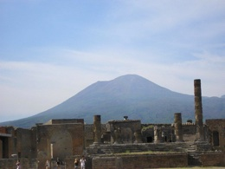
7:45 a.m. - Arrive in Rome. After going through Customs, depart Rome for Sorrento. Stop in Pompeii for lunch and a guided tour to visit the ruins of this ancient city destroyed by the great volcanic eruption of Mt. Vesuvius in 79 BC. Arrive in Sorrento in late afternoon.
Hotel – Sorrento: Grand Hotel Vesuvio www.vesuviosorrento.com
Meals Included: Breakfast (on the plane), Lunch and Dinner

DAY 3 – SUNDAY MAY 29, 2022:
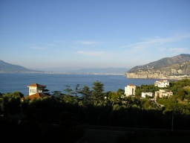
Breakfast at the Hotel.
Free Day in Sorrento.*

Optional Tour: Island of Capri, recognized as being one of the most beautiful islands in the entire Mediterranean Sea.
Hotel – Sorrento: Grand Hotel Vesuvio www.vesuviosorrento.com
Meals Included: Breakfast and Dinner

DAY 4 – MONDAY MAY 30, 2022:
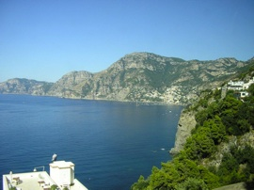
Breakfast at the Hotel.
8:30 a.m. – Depart Sorrento for a guided excursion along the Amalfi Coast, to enjoy the spectacular views of this stunning coastline with towns like Amalfi, Positano and Priano. Depart for Rome and arrive in late afternoon.
Hotel - Rome: Casa per Ferie Santa Maria alle Fornaci www.santamariafornaci.com
Meals Included: Breakfast and Dinner

DAY 5 – TUESDAY MAY 31, 2022:
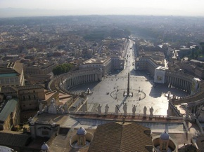
Breakfast at the Hotel.
8:30 a.m. – Panoramic Bus Tour of Rome followed by lunch. After Lunch, Guided tour of Vatican Museums and St. Peters. Visit the Sistine Chapel – with Michelangelo’s ceiling, which he single-handedly painted in the 4 years between 1508 & 1512; it rivets the visitor’s attention, along with the Last Judgment, which he painted decades later in his life. The frescoes on the side walls were painted by the great painters of the early Renaissance, Botticelli, Perugino, and Signorelli – and they also deserve the visitor’s attention. Our Tour Guide will show us all the highlights of the museum, which has the finest sculpture and tapestry collections in the world.
Visit St. Peter’s Basilica & Square – where Bernini’s curved porticoes extending outward from the Basilica to encompass the faithful like two welcoming arms – have defined the square visually for the last 4 centuries. The Basilica – by far the largest Church in the Christendom – is so large that even the human figure provides no useful reference! As an example, the baldachin or canopy over the altar, which is completely dwarfed by the vertical space around it, is as high as a 7-story building.
Evening Free.
Hotel - Rome: Casa per Ferie Santa Maria alle Fornaci www.santamariafornaci.com
Meals Included: Breakfast and Lunch

DAY 6 – WEDNESDAY JUNE 1, 2022:
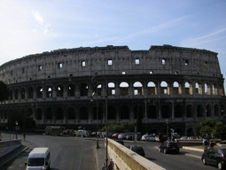
Breakfast at the Hotel.
9:00 a.m. – Walking tour of this famous city. Visit Fontana di Trevi, Pantheon, Piazza Navona, and many more.
Afternoon and evening free.
Hotel - Rome: Casa per Ferie Santa Maria alle Fornaci www.santamariafornaci.com
Meals Included: Breakfast

DAY 7 – THURSDAY JUNE 2, 2022:
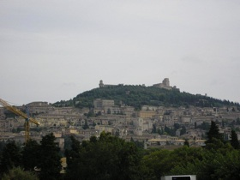
Breakfast at the Hotel.
8:30 a.m. - Depart for Florence. Stop at Assisi where we will visit the Basilica of Saint Francis. Giotto’s fresco cycle in the upper basilica on the life of Saint Francis was restored in record time by Italian art restorers after the earthquake of 1997 and is now open to the public. The lower basilica contains art by Italian medieval artists, as well as Saint Francis’ tomb. The visit continues with a stroll through the medieval streets to the main square, where the Roman temple to Minerva has been preserved. Arrive in Florence in the evening.
Hotel – Florence: Hotel California www.californiaflorence.it
Meals Included: Breakfast Lunch and Dinner

DAY 8 – FRIDAY JUNE 3, 2022:
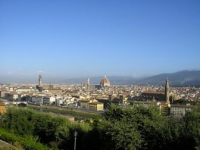
Breakfast at the Hotel.
8:30 a.m. - Guided tour of Florence. Visit this beautiful city where the Italian genius for art reached its pinnacle. The city flourished in the Middle Ages as a free commune. Florence is known as the cradle of Renaissance (La Cula del Rinascimento) for its monuments, churches and buildings. Enjoy a walking Guided Tour of the outdoor Duomo complex: Santa Maria del Fiore, the Baptistry with its bronze doors including the famous Porta del Paradiso, the Cathedral with the magnificent Cupola del Brunelleschi, and Giotto’s bell tower. A short walk through the historic streets of the heart of Florence brings you to the renowned Academy Gallery where you can admire the famous David by Michelangelo and other works by great artists. The tour will end with a visit inside the museum.
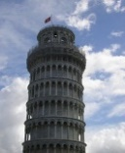
1:00 pm - Optional Tour of Pisa. Visit Miracle Square, with the celebrated Leaning Tower, the Baptistery and other important monuments. Visit the Cathedral – an unrivaled masterpiece of Romanesque art constructed between the 11th and 12th centuries. The power of Pisa as a mighty maritime nation reached its peak in the 11th century when it acquired traditional fame as one of the four main Maritime Republics of Italy.
Hotel – Florence: Hotel California www.californiaflorence.it
Meals Included: Breakfast

DAY 9 – SATURDAY JUNE 4, 2022:

Breakfast at the Hotel.
Free Day in Florence.
Hotel – Florence: Hotel California www.californiaflorence.it
Meals Included: Breakfast

DAY 10 – SUNDAY JUNE 5, 2022:

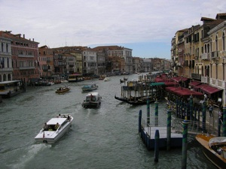
Breakfast at the Hotel.
9:00 a.m. - Depart Florence for Venice. Arrive in Venice in late morning. Visit the famous Rialto Bridge – the oldest of the four bridges crossing the spectacular Grand Canal. Crossing the Rialto Bridge will take you to the district of San Marco that is the center of trade and culture of the city. The heart of this district is the splendid and magnificent St. Mark’s Square, overlooking the most famous monuments of Venice: the splendid Byzantine Basilica with four portals and wonderful golden mosaics, the Renaissance Clock Tower, and the masterpiece of the Gothic Palazzo Ducale. Behind the Palazzo Ducale, from the Ponte di Paglia, you can admire the famous Bridge of Sighs that used to be crossed by the condemned people before entering prison – hence the name.
Hotel – Venice: Hotel Ambasciatori & Delfino,Venezia/Mestre
www.hotelambasciatori-mestre.com
Meals Included: Breakfast and Farewell Dinner

DAY 11 – MONDAY JUNE 6, 2022:
11:05 a.m. – Depart Venice for Newark, NJ on United flight # 169
2:35 p.m. – Arrive Newark, NJ.
Meals: Breakfast (at the hotel) lunch and dinner (on the plane).

Testimonials

- “An amazing trip on so many levels. Thank you for making it all possible”
- “We will never forget this trip….. We will be talking about this for years”
- “Thank you for a trip of a lifetime”
- “Two fabulous weeks, 46 great travel partners and one great leader…..Thanks for a terrific time”
- “Thank you for making our trip so memorable. You are so generous with your time and seeing to every detail”
- “Your caring, competent, fun-loving ways as a host and guide made our trip very enjoyable….”
- “Thank you for a lovely trip…Those two weeks shall hold a special meaning in my book of memories…”
- “What a wonderful time I had! Food was excellent, the group was super and the best of all was you, Lefty, for making it all happen…”
- “Thank you for the ‘unbelievable trip’ you planned. When I am asked by people about the trip I am truly at a loss for words to describe it…”
- “Thank you, thank you, thank you! The trip was wonderful. It was everything you said it would be and more. We will think about it and talk about it for years….”
- “Thank you for all you did before, during and after our trip to make this vacation so wonderful. What a blessing it was to see all the sights, meet all the terrific people and bring home memories of a lifetime.”
- “We salute you for producing such a superb trip; you are our leader extraordinaire! We had a fabulous adventure because you did such a tremendous job in handling all of the details.”
- “I can’t begin to tell you what a wonderful trip you planned for us. Many thanks for all the wonderful arrangements – you made every day so special…”

Terms and Conditions:

Deposit of $500.00 per person due at time of booking. The organizer acts only as your agent in managing the various accommodations and assumes no responsibility or liability in connection with any aircraft, motor coach or other conveyance, restaurant, excursions, sightseeing, or hotel accommodations in the performance of this tour. In the event it becomes necessary or advisable to alter the itinerary, such alterations will be made. Any additional expenses will be borne by the passenger(s).
Note: Airline/airport taxes/fees, fuel surcharge, and any increases due to exchange rate fluctuations will be reflected in the final invoice.
The tour is limited in size. In the event the tour is over-subscribed, reservations will be confirmed by the date deposit is received.
To reserve your seat(s), or to obtain additional information, call (724-331-6805) or e-mail Terry (“Lefty”) Pistentis or return the attached Reservation Form to the address below. You can also reserve your seat(s) by calling in your Credit Card information.

Make checks payable to: “Fanari Travel” and mail to:

Fanari Travel
PO Box 846
Greensburg PA 15601
Cell: 724-331-6805
E-mail: fanaritravel@gmail.com

Reservation Form

Please Reserve:

___ Seats for the “Taste of Italy - 2022” Tour.

Enclosed please find check for $ _______ payable to: “Fanari Travel”. I/we understand that in case of cancellation, the following refund policy applies:
- Up to 90 days prior to departure: Full Refund of Deposit
- 89 to 61 days: $500.00 penalty per person..
- 60 days or less or no-show: No refund.

PASSPORT INFORMATION EXACTLY AS IT APPEARS ON THE PASSPORT:
(Note: For dates, please use the day/month/year format and spell out the month.
Example: 7 MAY 1956)
NAME(S) (exactly as it appears on the Passport):
(Make copies for additional names, if needed)

FIRST:________________________ MIDDLE: ____________________ LAST:_____________________
DATE OF BIRTH ____________________________________
PASSPORT NUMBER ________________________________
PASSPORT EXPIRATION DATE _______________________________________
=================================================================================
FIRST:________________________ MIDDLE: ____________________ LAST:_____________________
DATE OF BIRTH ____________________________________
PASSPORT NUMBER ________________________________
PASSPORT EXPIRATION DATE _______________________________________
=================================================================================
Address: ____________________________________________________________

____________________________________________________________________

Phone (Home): _____________________________________________________

Phone (Cell): ______________________________________________________

E-mail: ____________________________________________________________

